Mesh generation in form of Penrose stairs

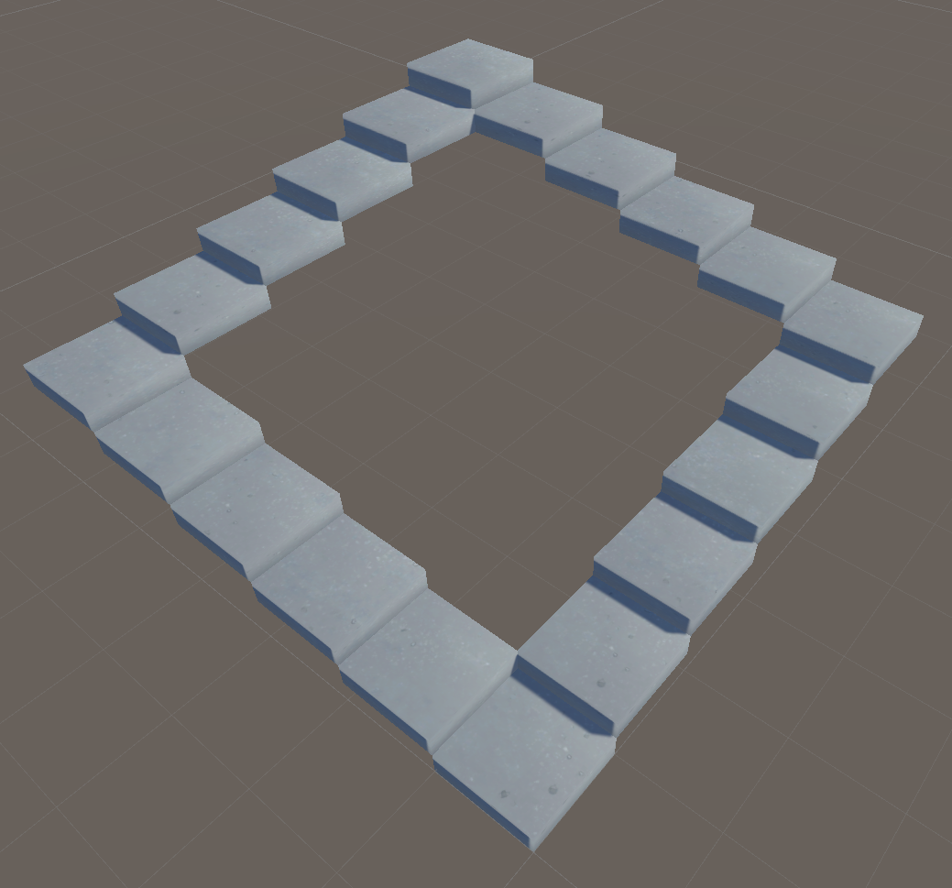

To start with this assignment, I first decided to wrap my head around things by just starting simple, drawing a single triangle. I added some Gizmos to the vertices for debugging purposes to see if I’m placing/connecting them right. I used a property to count from 0 to 2 since I needed that for the vertexes, triangles and uv-s. For later iterations I decided to discard this way of working, since it caused unintentional behaviour. Since it increments itself in the get, if you use breakpoints to debug it, it’ll keep incrementing itself since every time you hover over it to display its value, it has to get the variable. Each iteration I added more faces, till I had 3 faces. For these stairs that I’d be making I didn’t need more than 3 faces, since the other 3 faces to make a full cube wouldn’t be seen anyway.

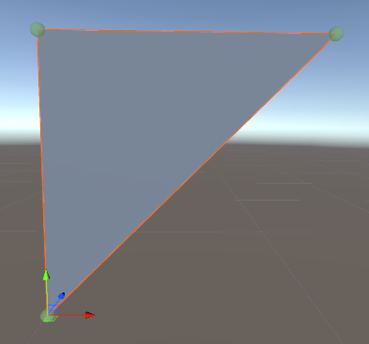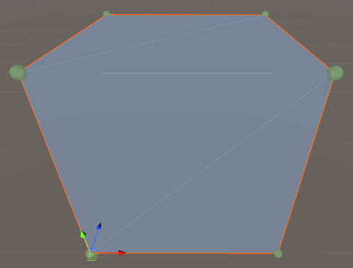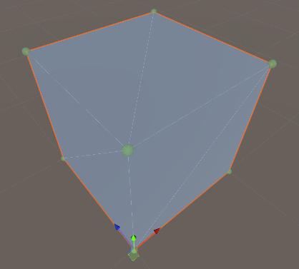



  1   using UnityEngine;

  2

  3   public class TriangleTest : MonoBehaviour

  4   {

  5       Color debugColor = new(0.310f, 0.620f, 0.275f, 0.75f);

  6       Mesh mesh;

  7       private int length = 2;

  8       private int _i;

  9       private int i

 10       {

 11           get

 12           {

 13               if (_i > length)

 14                   _i = 0;

 15               return _i++;

 16           }

 17       }

 18

 19       [ContextMenu(nameof(Start))]

 20       void Start()

 21       {

 22           mesh = GetComponent<MeshFilter>().mesh;

 23

 24           Vector3[] vertices = new Vector3[3];

 25

 26           vertices[i] = new Vector3(0, 0, 0);

 27           vertices[i] = new Vector3(0, 1, 0);

 28           vertices[i] = new Vector3(1, 1, 0);

 29

 30           int[] tris = new int[3];

 31           tris[i] = 0;

 32           tris[i] = 1;

 33           tris[i] = 2;

 34

 35           Vector2[] uvs = new Vector2[3];

 36           uvs[i] = new Vector2(0, 0);

 37           uvs[i] = new Vector2(0, 1);

 38           uvs[i] = new Vector2(1, 0);

 39

 40           mesh.vertices = vertices;

 41           mesh.triangles = tris;

 42           mesh.uv = uvs;

 43       }

 44

 45       private void OnDrawGizmos()

 46       {

 47           if (mesh == null) return;

 48

 49           Gizmos.color = debugColor;

 50

 51           for (int i = 0; i < mesh.vertices.Length; i++)

 52               Gizmos.DrawSphere(mesh.vertices[i], .025f);

 53       }

 54   }

Once I had my base stair (same as the half-cube), I used it to infinitely add stairs through a [SerializeField] in the inspector of the script. Once I added this I need to figure out a way to bend the stairs every so often. For this I decided to make another [SerializeField] for after how many stairs, the stair bends. For my purposes of creating the ‘infinite’ staircase I made it have a maximum of four bends. If the Stair Bend Count is not a multiple of 4 of Stair Count or greater, it’ll end up not finishing the stairs. However if the amount of stairs exceed a multiple of four on the Stair Bend Count, it’ll be capped off (line 70).

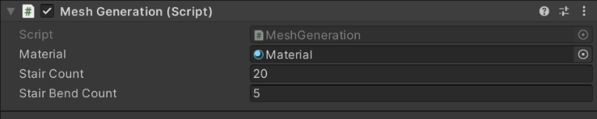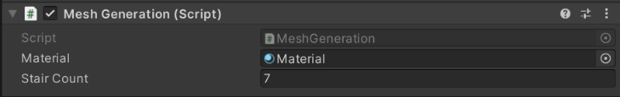

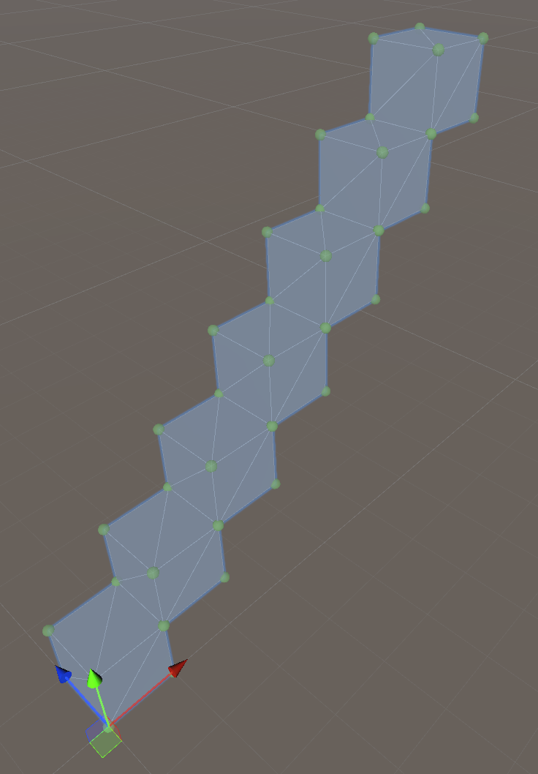

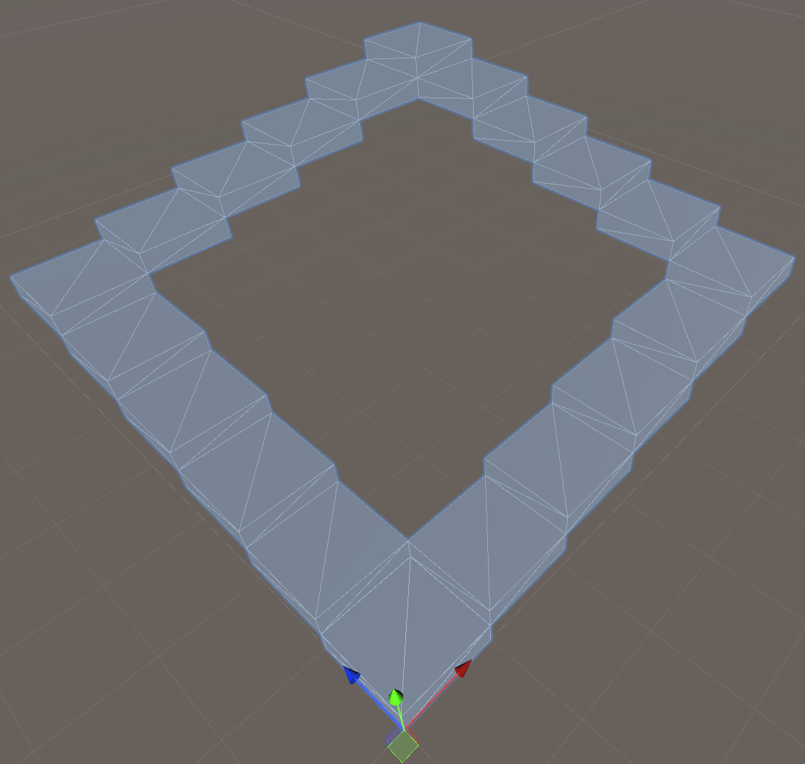

Let’s dive a bit deeper into the code. The main logic is within the Pos function from line 20 to 30. Here it takes in the x, y, z of the vertex which it uses to scoot up/down each iteration of stair, by incrementing/decrementing the i accordingly. It may look complicated, but it’s quite simple really. Each time I’m comparing sBC (stairBendCount) to the for loop index. Upon this comparison I calculate what state the coordinate needs to be in. The coordinate can have one of three states; incrementing, decrementing or staying equal relatively. The ‘random’ magic numbers are used to indicate at what bend the stair is at, since there are only four bends maximum, each bend would be a multiple, so multiple two for bend two, multiple three for bend three and so on.

  1   using UnityEngine;

  2

  3   public class MeshGeneration : MonoBehaviour

  4   {

  5       [SerializeField] private Material material;

  6       [SerializeField] private int stairCount;

  7       [SerializeField] private int stairBendCount;

  8

  9       Vector3[] verts = new Vector3[7];

 10

 11       int[] tris = new int[18];

 12

 13       private Mesh mesh;

 14       private GameObject meshObject;

 15

 16       private void GenerateMesh()

 17       {

 18           for (int i = 0; i < stairCount; i++)

 19           {

 20               Vector3 Pos(int x, int y, int z = 0)

 21               {

 22                   int sBC = stairBendCount;

 23

 24                   return new Vector3(

 25                       i < sBC ? x + i : i < sBC * 2 ? x + sBC :

 26                       i < sBC * 3 ? x - i + sBC * 3 : x,

 27                       i < sBC * 2 ? y + i : y - i + sBC * 4,

 28                       i < sBC ? z : i < sBC * 2 ? z + i - sBC :

 29                       i < sBC * 3 ? z + sBC : z - i + sBC * 4);

 30               }

 31

 32               verts[0] = Pos(0, 1);

 33               verts[1] = Pos(1, 1);

 34               verts[2] = Pos(0, 0);

 35               verts[3] = Pos(1, 0);

 36

 37               verts[4] = Pos(0, 1, 1);

 38               verts[5] = Pos(1, 1, 1);

 39

 40               verts[6] = Pos(0, 0, 1);

 41

 42               tris[0] = 0;

 43               tris[1] = 1;

 44               tris[2] = 2;

 45

 46               tris[3] = 2;

 47               tris[4] = 1;

 48               tris[5] = 3;

 49

 50

 51               tris[6] = 0;

 52               tris[7] = 4;

 53               tris[8] = 5;

 54

 55               tris[9] = 0;

 56               tris[10] = 5;

 57               tris[11] = 1;

 58

 59

 60               tris[12] = 2;

 61               tris[13] = 6;

 62               tris[14] = 0;

 63

 64               tris[15] = 4;

 65               tris[16] = 0;

 66               tris[17] = 6;

 67

 68               CreateMesh();

 69

 70               if (i > stairBendCount * 4 - 1) break;

 71           }

 72       }

 73

 74       private void CreateMesh()

 75       {

 76           mesh = new();

 77

 78           mesh.vertices = verts;

 79           mesh.triangles = tris;

 80

 81           meshObject = new GameObject(nameof(meshObject));

 82           meshObject.AddComponent<MeshFilter>().mesh = mesh;

 83           meshObject.AddComponent<MeshRenderer>().material = material;

 84

 85           meshObject.transform.parent = transform;

 86           meshObject.transform.localScale = new Vector3(1, 0.25f, 1);

 87       }

 88

 89       [ContextMenu(nameof(RegenerateMesh))]

 90       private void RegenerateMesh()

 91       {

 92           for (int i = transform.childCount - 1; i >= 0; i--)

 93               DestroyImmediate(transform.GetChild(i).gameObject);

 94

 95           GenerateMesh();

 96       }

 97

 98       void Start() => GenerateMesh();

 99   }

After this I still had to implement the uvs properly because they weren’t working yet, I also had to convert the all the gameobjects into one mesh, because currently it was creating a gameobject for each stair, which is excessive. I did this by adding the coordinates to a list and generating it once every coordinate is generated. As for the uv’s (line 58 to 66), I mapped them to the vertices. However this would then always give the same boring result, so I decided to give it a randomised offset with Random.value Now each time the mesh is generated, every stair will have their own unique UV coordinates; whilst still being relative to the original UV-positioning, so the textures do not get stretched.

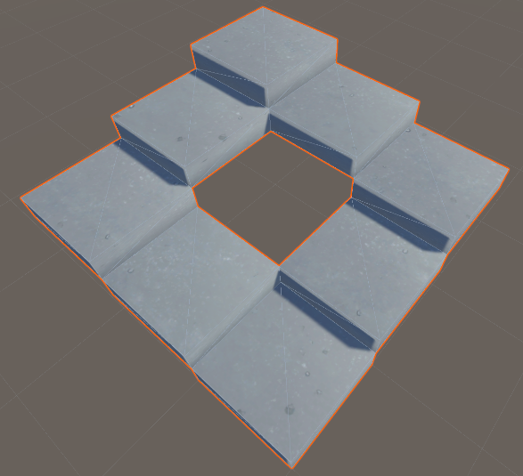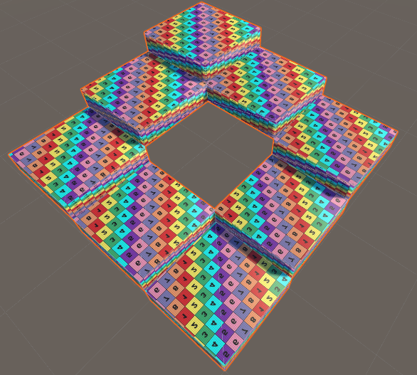

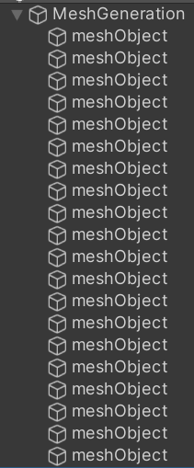



I also decided to clean up the way I entered data for the tris. Instead of having to explicitly state what array position I want to affect, I just create a new integer array and enter the coordinates that way. Whilst still not the most elegant solution, it is better than what it was. To keep track of which stair I’m at, and to add the tris relative to that stair, I multiply the index with the amount of vertexes per stair (line 32), which is seven.

   1   using System.Collections.Generic;

   2   using UnityEngine;

   3

   4   public class MeshGeneration : MonoBehaviour

   5   {

   6       [SerializeField] private Material material;

   7       [SerializeField] private int stairCount;

   8       [SerializeField] private int stairBendCount;

   9

  10       private List<Vector3> verts = new();

  11       private List<Vector2> uvs = new();

  12       private List<int> tris = new();

  13

  14       private Mesh mesh;

  15

  16       private void GenerateMesh()

  17       {

  18           for (int i = 0; i < stairCount; i++)

  19           {

  20               Vector3 Pos(int x, int y, int z = 0)

  21               {

  22                   int sBC = stairBendCount;

  23

  24                   return new Vector3(

  25                       i < sBC ? x + i : i < sBC * 2 ? x + sBC :

  26                       i < sBC * 3 ? x - i + sBC * 3 : x,

  27                       i < sBC * 2 ? y + i : y - i + sBC * 4,

  28                       i < sBC ? z : i < sBC * 2 ? z + i - sBC :

  29                       i < sBC * 3 ? z + sBC : z - i + sBC * 4);

  30               }

  31

  32               int vertCount = i * 7;

  33

  34               verts.AddRange(new Vector3[] {

  35                   Pos(0, 1),

  36                   Pos(1, 1),

  37                   Pos(0, 0),

  38                   Pos(1, 0),

  39                   Pos(0, 1, 1),

  40                   Pos(1, 1, 1),

  41                   Pos(0, 0, 1),

  42               });

  43

  44               tris.AddRange(new int[] {

  45                   vertCount, vertCount + 1, vertCount + 2,

  46                   vertCount + 2, vertCount + 1, vertCount + 3,

  47                   vertCount, vertCount + 4, vertCount + 5,

  48                   vertCount, vertCount + 5, vertCount + 1,

  49                   vertCount + 2, vertCount + 6, vertCount,

  50                   vertCount + 4, vertCount, vertCount + 6

  51               });

  52

  53               float random = Random.value;

  54               Vector2 OffSet(int x, int y) => new(

  55                   x + (i + 1) * random,

  56                   y + (i + 1) * random);

  57

  58               uvs.AddRange(new Vector2[] {

  59                   OffSet(0, 1),

  60                   OffSet(1, 1),

  61                   OffSet(0, 0),

  62                   OffSet(1, 0),

  63                   OffSet(0, 0),

  64                   OffSet(1, 0),

  65                   OffSet(1, 0),

  66               });

  67

  68               if (i > stairBendCount * 4 - 1) break;

  69           }

  70

  71           CreateMesh();

  72       }

  73

  74       private void CreateMesh()

  75       {

  76           if (mesh == null)

  77               mesh = new Mesh();

  78

  79           mesh.Clear();

  80           mesh.vertices = verts.ToArray();

  81           mesh.triangles = tris.ToArray();

  82           mesh.uv = uvs.ToArray();

  83           mesh.RecalculateNormals();

  84

  85           if (!GetComponent<MeshFilter>())

  86               gameObject.AddComponent<MeshFilter>();

  87           if (!GetComponent<MeshRenderer>())

  88               gameObject.AddComponent<MeshRenderer>();

  89

  90           GetComponent<MeshFilter>().mesh = mesh;

  91           GetComponent<MeshRenderer>().material = material;

  92       }

  93

  94       [ContextMenu(nameof(RegenerateMesh))]

  95       private void RegenerateMesh()

  96       {

  97           verts.Clear();

  98           uvs.Clear();

  99           tris.Clear();

 100           GenerateMesh();

 101       }

 102

 103       void Start()

 104       {

 105           GenerateMesh();

 106       }

 107

 108       private void Update()

 109       {

 110           if(Input.GetKeyDown(KeyCode.Q))

 111               RegenerateMesh();

 112       }

 113   }

*ChatGPT 3.5 and 4.0 were used in the making of this project.*

*The paper trail consists of four chats:* [*chat one*](https://chat.openai.com/share/de9f8cae-b083-43ea-8746-11a9bddd28f6)*,* [*chat two*](https://chat.openai.com/share/d87c56bf-c18e-471f-a229-9cfe543569fd)*,* [*chat three*](https://chat.openai.com/share/4a9fad2a-30ac-4352-bebe-8dfd5f98637e) *and* [*chat four*](https://chat.openai.com/share/58ca701d-1a5d-4f9d-b557-9017c1e7ab9b)